Error test | inputs | Expected outcome | Acutaly outcome | changes
Checking if all the correct pages load | n/a | Pages index login and register should load | All pages loaded but an error has occered when checking if we have access to the database in index  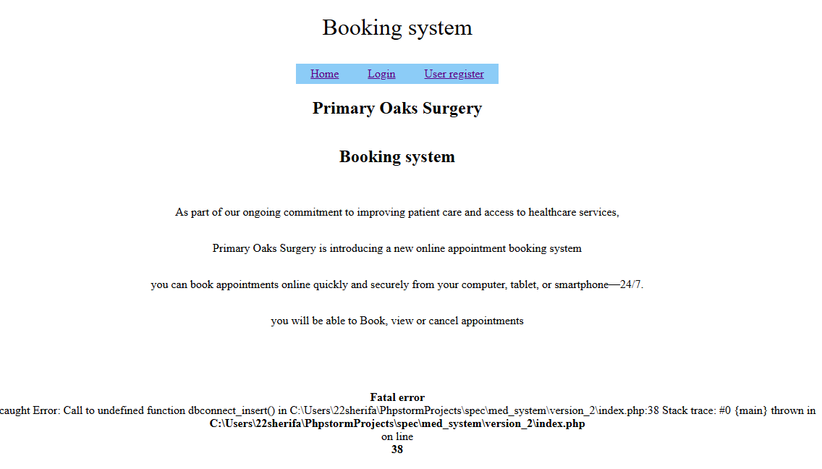  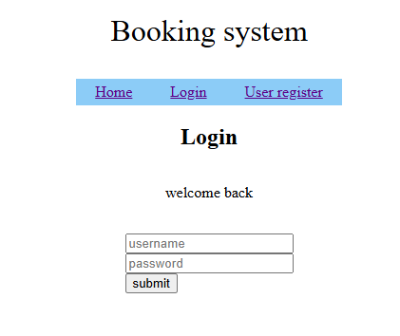  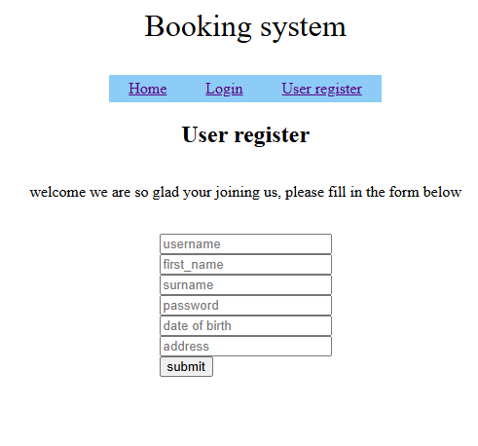  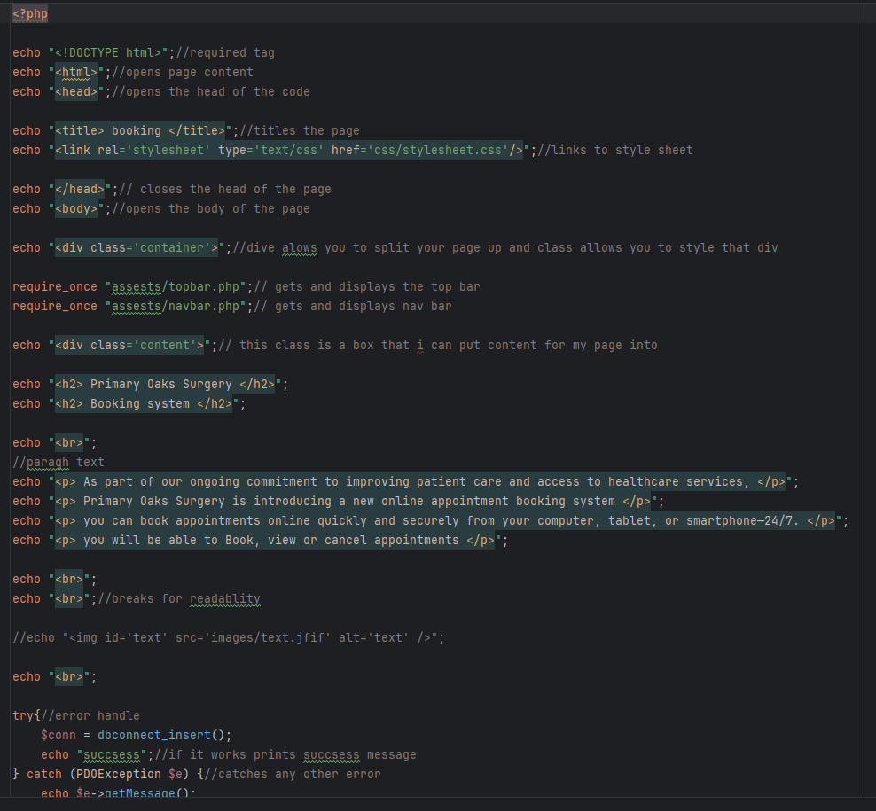 | In this code we can see im missing some bits of code like session start calling the user message and the the subroutines that allow me to check database access and print the user message so I just needed to add this in  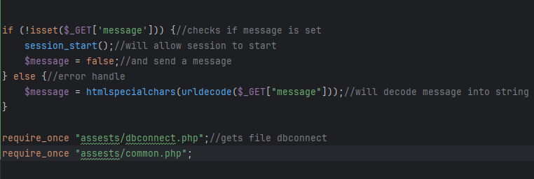  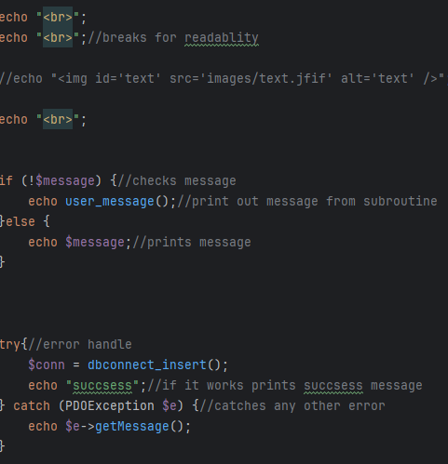  and here we can see ive added the code in that connects to the subroutine and is able to print out user messages and connect to database so should not have an issue now
Checking everything now loads with no error | n/a | Pages index, register and login should load without any errors | 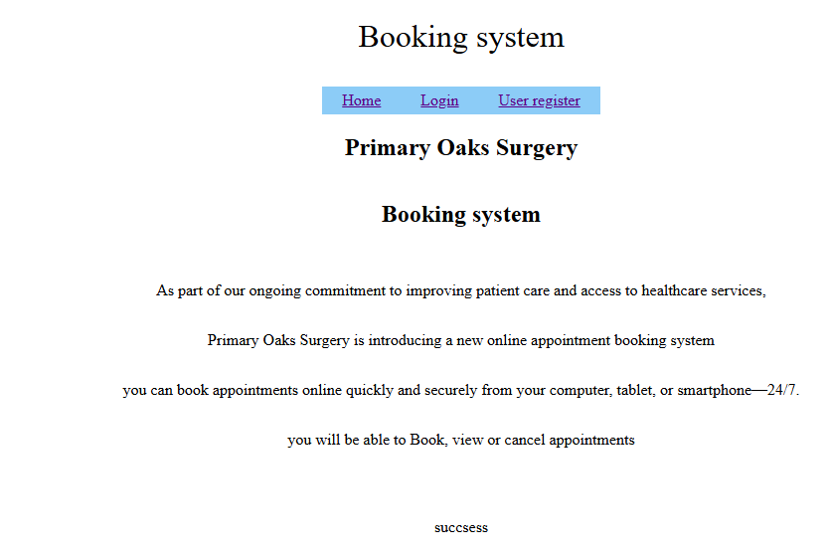  As we can see they all loaded correctly with no errors | n/a
Checking I can register | Avas  ava  sheriff  password  15/08/1008  hello | Should say registaion successful and add user to data base | I got an error saying a user table dosnt exisist so it can add the data in common | The issue was my table in my database was called users not user and I had it in my code as user so I just needed to change the spelling  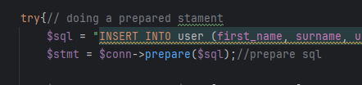  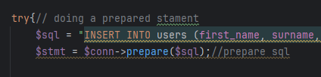
Checking user register now is fixed | Avas  ava  sheriff  password  15/08/1008  hello | Should say registaion successful and add user to data base | I got this error saying that my value where not quite right, | 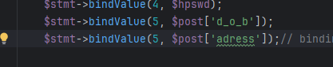  This issue here was that I had binded 2 values to 5 so it didn’t match, to fix this I justed needeed to bind the adress to 6 not 5
Checking the registation now works | Avas  ava  sheriff  password  15/08/1008  hello | Should say regstation successfuland add data to user data base | 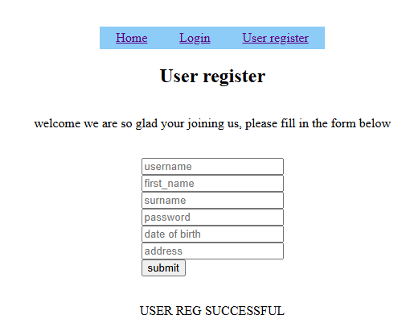  All log in ok without an issueand added to database. | n/a
Checking I can login | Avas  password | Should allow me to log in with account and show other pages and show success | 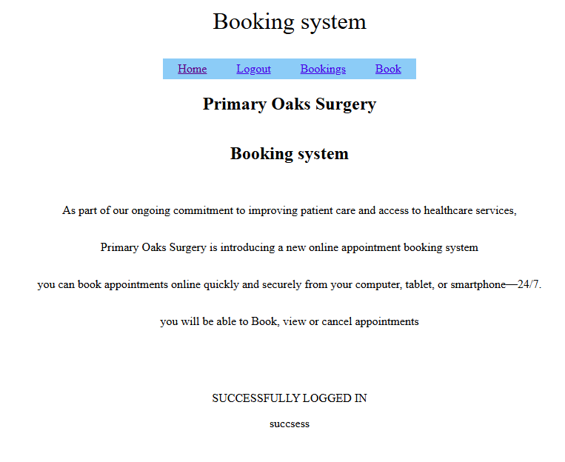  Gave me a success message and allowd me to log in ok | n/a
Checking the password checker works and dosent accept a password its not supposed to | 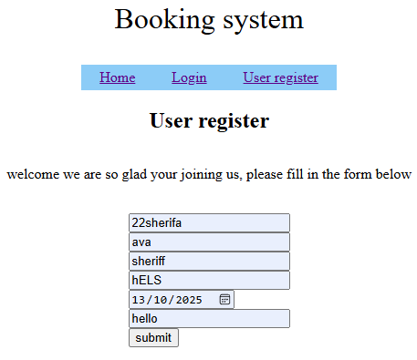 | Should give an error andd not allow it to enter into the data base | 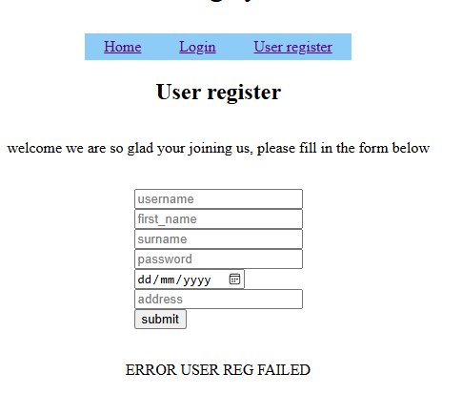  An error was given correctly and no data was daded to the database as the password was not valid and didn’t pass all the checks | n/a
Checking that the password checker accepts the passwords | 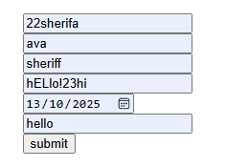 | Should say user reg success and put the data into the data base | 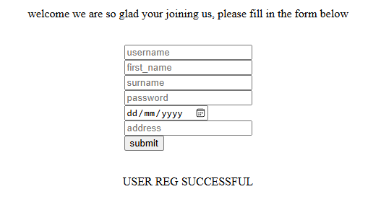  As we can see it works as inteneded and the password and details are accepted and will be added to the data base | n/a
Checking that the data fillters so it dosnet crash | 22sherifa<heelooo>  ava()  sheriff....S  hELlo!23hi<l>  13/10/2025  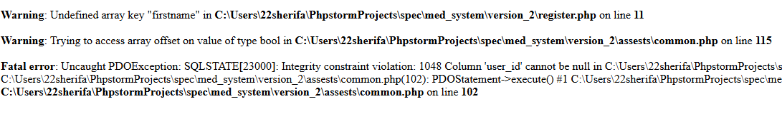  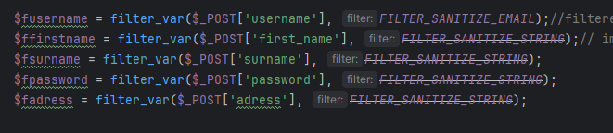  hellohttps://www.google.com/?safe=active&ssui=on | Should take out any urls or scrips anything that could be a security issue from the string to make sure the website is secure | Here we have an erroe saying that the data and the subroitines are having issues causing unfiltered data to be enterd into the data base, | The issue here with this code is that we are assining each fillerted value to a varuable however in the rest of the code we used post with is a array of all these veriable meaning the unfiltered data was being passed and casuing issues,  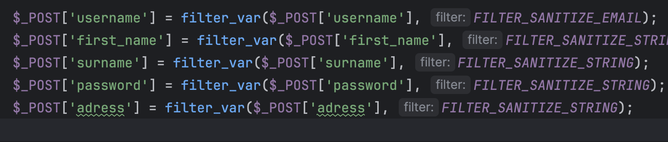  here we can see I fixed the code by just filtering the value in the orginal post veriable so the data in post gets filtered and is still in the post subroutine
Checking that the filltering of inputs works | maryams<kk>  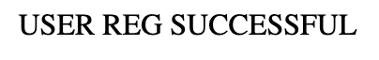  maraym<//:https>  sheriff<MMM>  hELloo123?hi  13/10/2025  hellohttps://www.google.com/ | I used the correct acceptible password to check when the data is added to the data base it will be filtered so this should let the user register but the data in the data base should not have any scrpts or malisue code | Here we can see that the user registation was successful and we can see the data in the data base has been filtered of the masuise inputs | n/a

